Ideation Phase
Brainstorm & Idea Prioritization Template

Date | September 25, 2026
Team ID | SWTID-2026-1591
Project Name | AI BlogNest API
Maximum Marks | 4 Marks

Step-1: Team Gathering, Collaboration and Select the Problem Statement
Team Members:
- Ramani S
- Sakthi Jayathra S
- Kavitha M
- Vedhavalli S
Selected Problem Statement:
Content creators struggle to manage multiple blog posts, organize categories and tags and spend a lot of time writing summaries and generating new content. There is a need for a smart backend system that automates these tasks using Artificial Intelligence.

Step-2: Brainstorm, Idea Listing and Grouping
Idea Number | Idea Description
Idea 1 | Simple Blog CRUD API (No API)
Idea 2 | Blog API with JWT Authentication
Idea 3 | AI Blog Generation using Google Gemini AI
Idea 4 | AI Blog Summarization
Idea 5 | Role-Based Access Control  (Admin, Editor,Author, Reader)
Idea 6 | Category and Tag Management
Idea 7 | Comment Moderation System
Idea 8 | Search and Filter Blogs

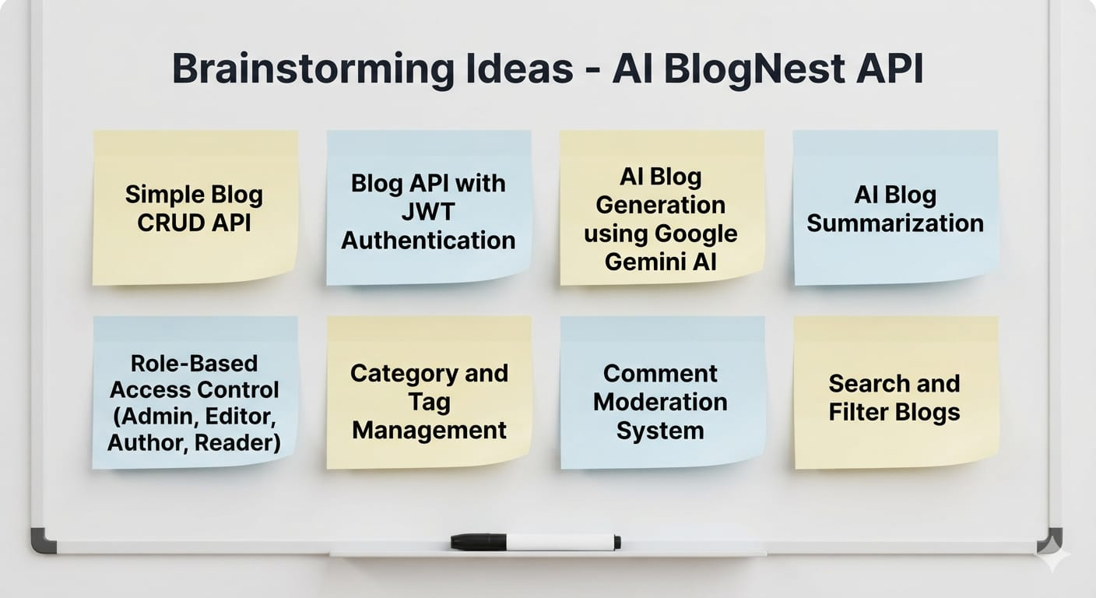

Step-3: Idea Prioritization
PRIORITY QUADRANT | IDEAS
High Importance, High Feasibility | AI Blog Generation, JWT Authentication, Blog CRUD
High Importance, Low Feasibility | Comment Moderatiion, Role-Based Access Control
Low Importance, High Feasibility | Category & Tag Management, Search & Filter
Low Importance, Low Feasibility | Advanced Analytics Dashboard

